**Module 18 – Pivot Tables**

**Exercise**

1. Open the file called **Pivot Table**.
2. Click inside the table and insert a new, blank Pivot Table on a new sheet.
3. Add fields to the blank Pivot Table so that it looks like the table below:

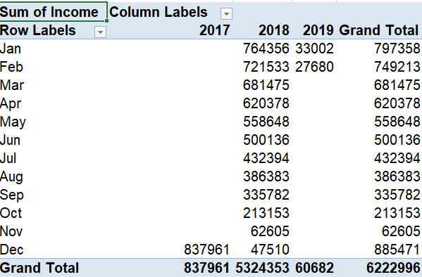

1. Remove the fields.
2. Add fields to the blank Pivot Table so that it looks like the table below. Use the Year field as your filter and show the year 2019.

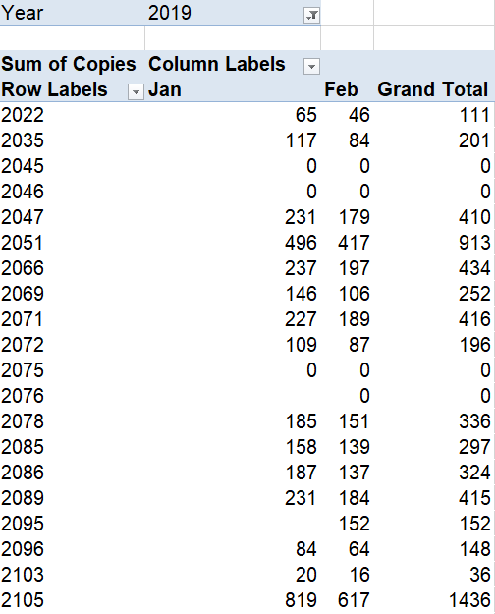

1. Using the Field Settings button, change “Sum of Copies” to say “# of Copies”.
2. Change all of the numbers to $.
3. Rename sheet 2 to “Pivot Table”.
4. Save and close the file.